Prometheus + Grafana + Spring Boot Actuator flow

video to set up(coming soon)

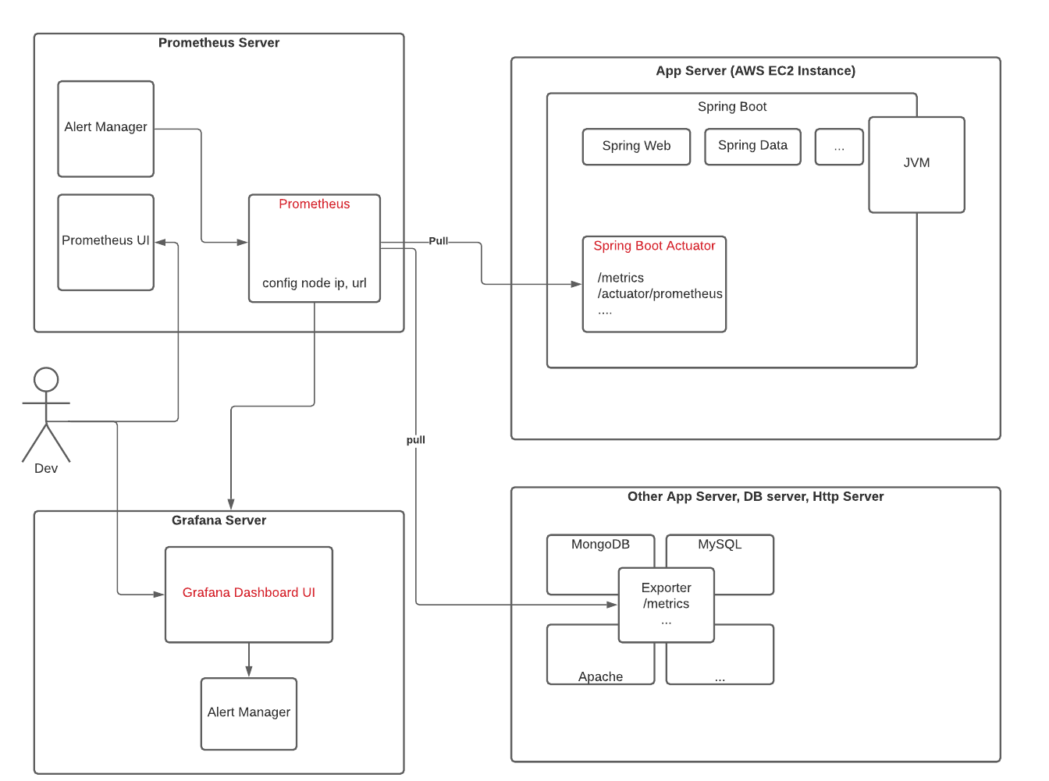

Prometheus UI

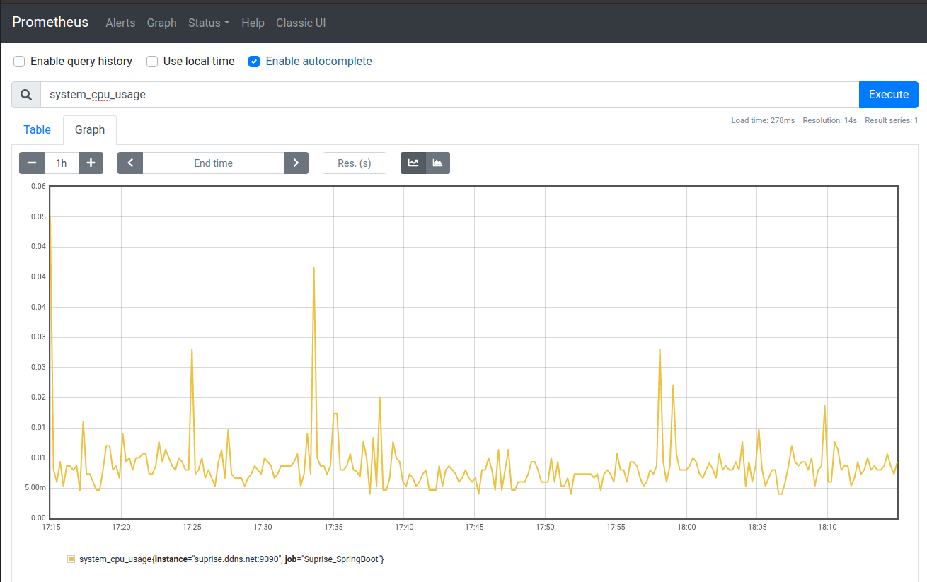

Grafana Dashboard

